To,

The *Sprocket Central Pty Ltd:*

After initial inspection of the data provided, I have detected the following issues in my assessment of the data quality. Issues are addressed according the the data files:

**CustomerAddress :**

Data for three states is recorded in the country of Australia. These are New South Wales, Victoria and Queensland.

I have abbreviated all state names as follows:

New South Wales = NSW

Victoria = VIC

Queensladn = QLD

A tableau dashboard showing the number of records for each state and average property valuation.

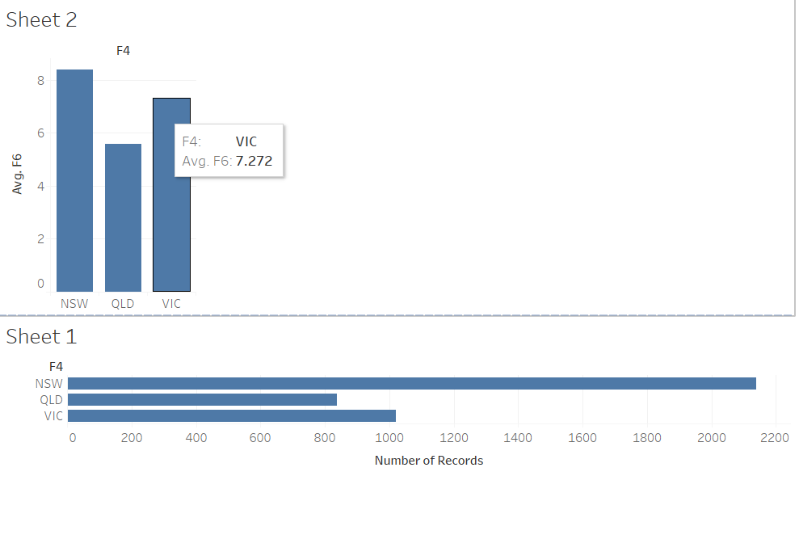

**Transactions :**

Changing the date format to better understand the column.

Some values are missing.

Data like Offline and Cancelled transactions are not needed and can be removed.

**Customer Demographics:**

Gender – Only three categories M , F , U are needed.

Calculating age based on data to add a field which can be needed.

Default column : No insights / knowledge can be uscertained and the column was removed.

Deceased entries filtered.

These changes have made the data more appropriate for further analysis.

Regards,

Rohit Bhalerao.